|  |  |  |  |  |  |  |  |  |
| --- | --- | --- | --- | --- | --- | --- | --- | --- |
|  | Type of Document  Technical Note | | | Document ID  9ADB004451-014 | | Classification  **Confidential** | Date | Status  Draft |
|  | Author Location  Dättwil | Author Dept.  CH-RD.P3 | | Author Name  Deran Maas | | | Phone | |
|  | Approver Location  Dättwil | Approver Dept.  CH-RD. | | Approver Name | | | Date of Approval | |
|  | Title  **LEAP Design Draft** | | | | | | | |
|  | Recipient Location | Recipient Dept | | Recipient Name | | | Notes for Recipient | |
|  | Frankfurt | ATG-FE | | Juergen Kappler | | |  | |
|  | Frankfurt | ATG-FEA | | Stefan Bleil | | |  | |
|  |  |  | |  | | |  | |
|  |  |  | |  | | |  | |
|  | CRID  10710 | | Local Project No. | | Project Name  LEAP - Laser Engine for gas Analyzer Platform | | | |
|  | Customer | | Keywords  Tunable Diode Laser Absorption Spectroscopy (TDLAS) | | | | | |

Summary

This document describes TDLAS in general. The design of the project is given in separate documents.

Table of contents

1 Introduction 3

1.1 Cross stack design 3

1.2 Insertion tube design 3

1.3 Extractive design 3

2 TDLAS technology 3

2.1 Description 3

2.2 Challenges 4

3 Design 4

3.1 Transmitter 4

3.2 Receiver 5

3.3 System 6

4 References 6

# Introduction

Tunable diode laser absorption spectroscopy (TDLAS) is a technique for measuring concentrations of certain species in gaseous mixtures. A TDLAS system typically has a transmitter and a receiver unit, see Figure 1. The transmitter emits a laser beam, which propagates through the gas to be measured. The receiver measures the laser beam using a photo detector and computes the gas concentration. To correctly compute the concentration the sensor needs to know the process temperature and pressure.

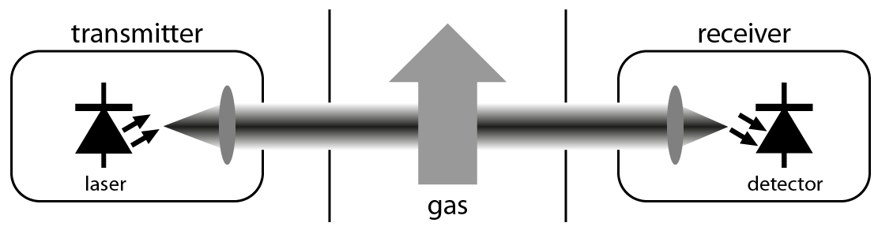

Figure : Example of a TDLAS sensor. The cross stack system consists of a transmitter and a receiver unit. The transmitter contains a wavelength tunable laser and the receiver contains a photo detector to measure the transmitted light. A small fraction of the light is absorbed in the stack.

## Cross stack design

In a cross stack configuration the transmitter and receiver are in separate housings. The laser beam should be aligned at the receiver. The optical path length can vary between 20 cm and 20 m. Optical windows are needed to separate the process (high temperatures and high pressures) from the sensor.

## Insertion tube design

The transmitter and receiver are in the same housing. A tube with a reflector is inserted in the process.

## Extractive design

The extractive sensor has a separate gas cell to perform the measurement. Higher sensitivity can be obtained by using multi pass cells or enhancement cavities.

# TDLAS technology

## Description

The optical light source is a tunable diode laser. Two common types are the vertical-cavity surface-emitting laser (VCSEL) and the distributed feedback laser (DFB). The wavelength of the laser is scanned in a short time interval (typically ms range). Typical scanning ranges are around 1 nm. Tuning of the laser is done by changing the diode current, see Figure 2.

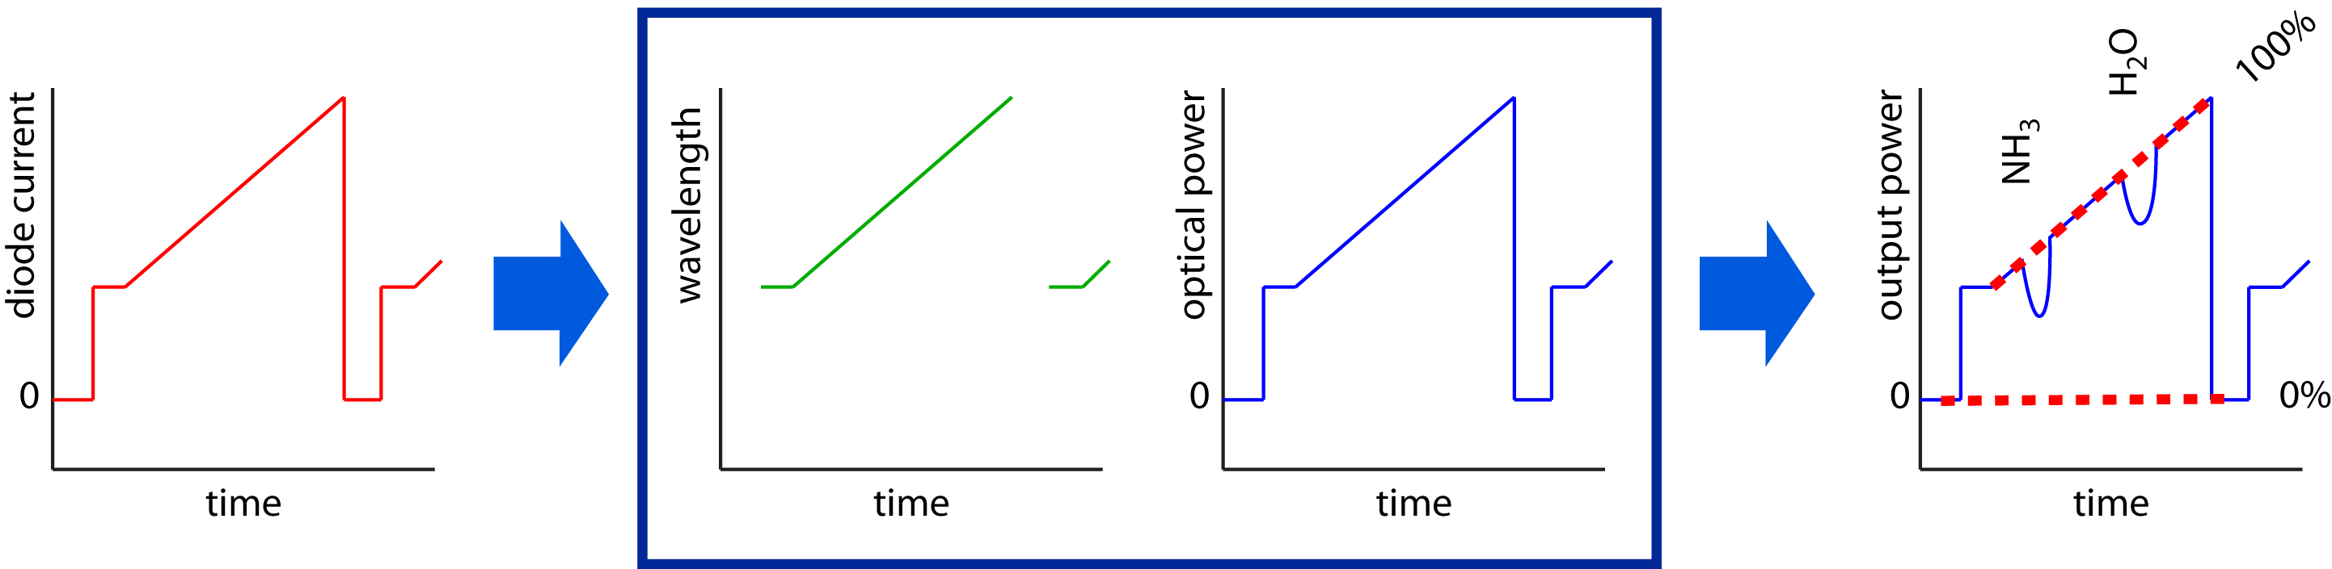

Figure : TDLAS example. The current through the laser diode is increased, as a result the wavelength changes and also the optical output power. At certain wavelength the gas absorbs the light and the transmission reduces. By using advanced algorithms the receiver can compute the concentration.

## Challenges

The challenges to build a TDLAS system are:

* Transmitter electronics: the generation of the waveform to modulate the laser is very critical. Experiments with a digital waveform generator were unsuccessful.
* Receiver electronics: a very low noise high speed acquisition (with variable gain) is needed.
* Optical fringes: the performance of typical TDLAS systems is limited by fringe effects (due to the monochromatic light).
* Cross interference: cross inference happens if gasses have overlapping absorption lines or one gas changes the line shape of the other gas. Intelligent signal processing is needed to reduce this cross interference.

# Design

## Transmitter

The transmitter contains the following blocks:

* waveform generator (to generate the modulation of the laser)
* laser driver
* laser protection circuits
* digital control unit
* digital temperature controller
* piezo actuator (to reduce fringes)
* laser

The electronics are described in [1].

The digital temperature controller is described in [2].

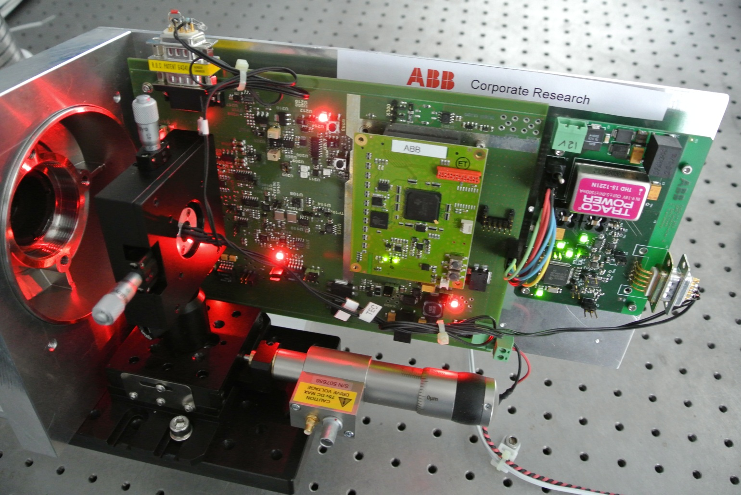

Figure : Picture of the transmitter (concept demonstrator LEAP).

## Receiver

The receiver contains the following blocks:

* photo detector
* analog front end with variable gain
* analog digital converter
* microprocessor

The electronics are described in [3].

Currently the receiver averages the data and sends the averaged signal via USB to a computer. The signal processing is done on this computer.

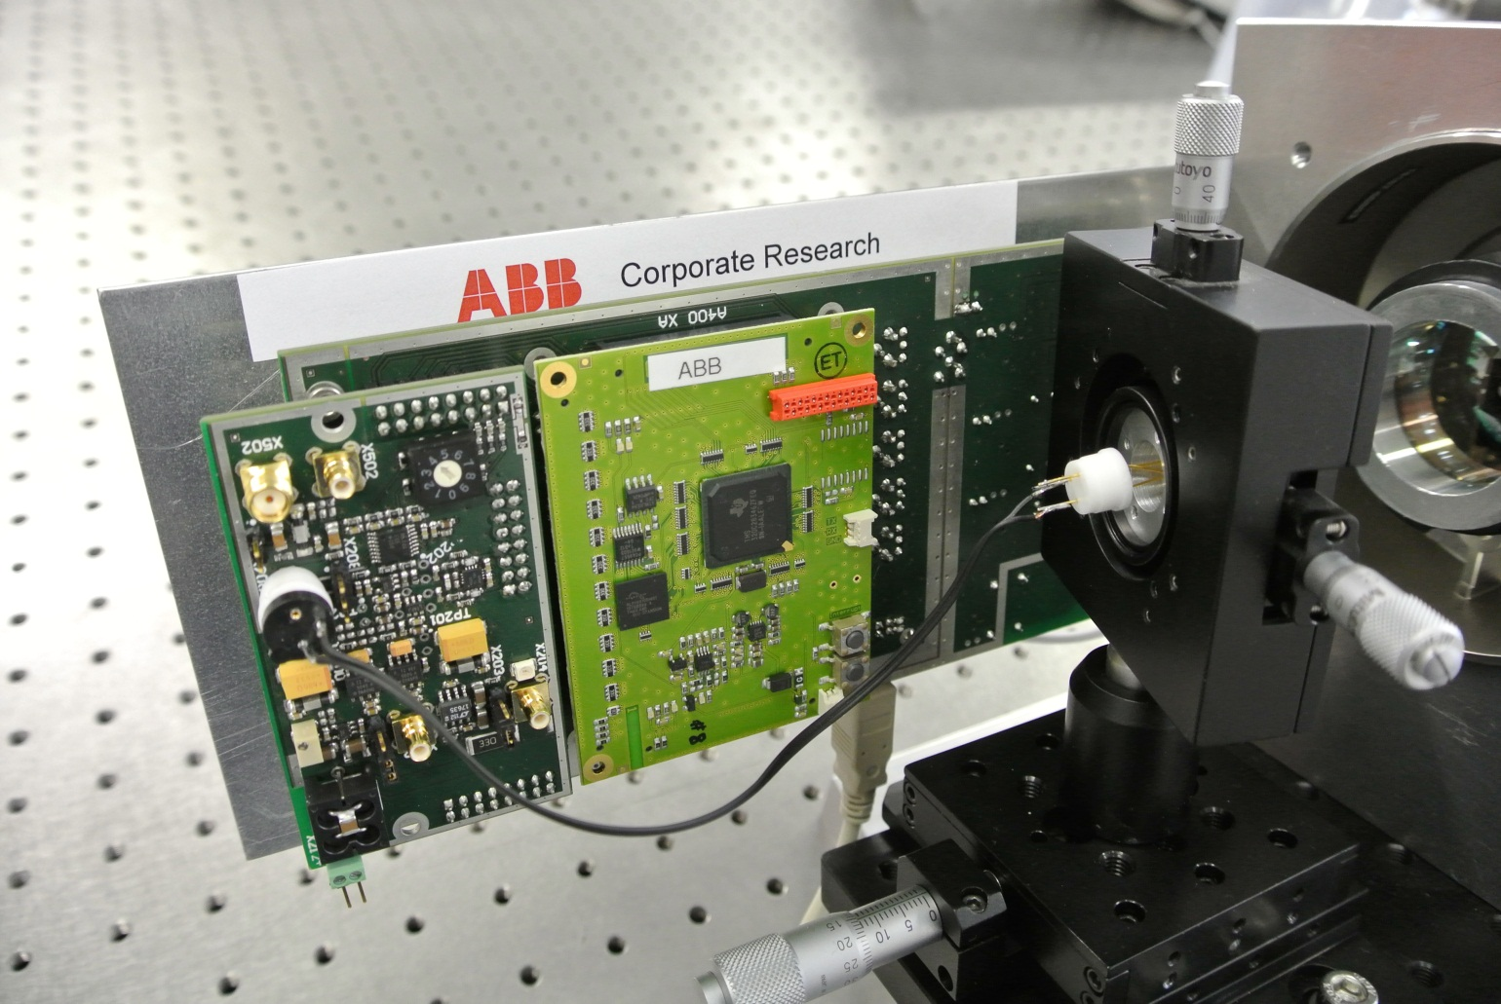

Figure : Picture of the receiver (concept demonstrator LEAP).

## System

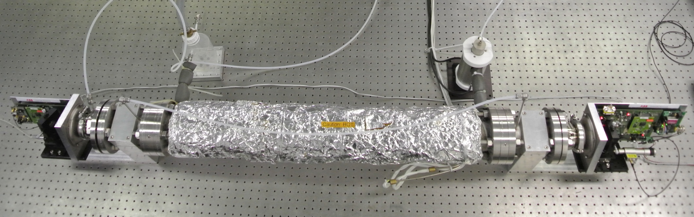

Figure : Picture of the system.

First experimental results are described in [4].

# References

1. 9ADB004451-009, LEAP Technical Documentation 3 – Transmitter
2. 9ADB004451-010, LEAP Technical Documentation 4 – Temperature Controller
3. 9ADB004451-011, LEAP Technical Documentation 5 – Receiver
4. 9ADB004451-012, LEAP Technical Documentation 6 – Optical Design

Change History

|  |  |  |  |
| --- | --- | --- | --- |
| **Rev.** | **Chapter** | **Description** | **Date / Dep. / Name** |
| 01 | All | Initial Document | <yyyy-mm-dd> / CH-RD.<dep> / <name> |
|  |  |  |  |
|  |  |  |  |
|  |  |  |  |
|  |  |  |  |
|  |  |  |  |
|  |  |  |  |
|  |  |  |  |
|  |  |  |  |
|  |  |  |  |

Review History

|  |  |  |  |
| --- | --- | --- | --- |
| **Rev.** | **Chapter** | **Reviewer(s)** | **Date** |
| 01 | All | <name> / <dep.> | <yyyy-mm-dd> |
|  |  |  |  |
|  |  |  |  |
|  |  |  |  |
|  |  |  |  |
|  |  |  |  |
|  |  |  |  |
|  |  |  |  |
|  |  |  |  |
|  |  |  |  |